Inception Report: Geospatial and Health Data System Strengthening in Niger State

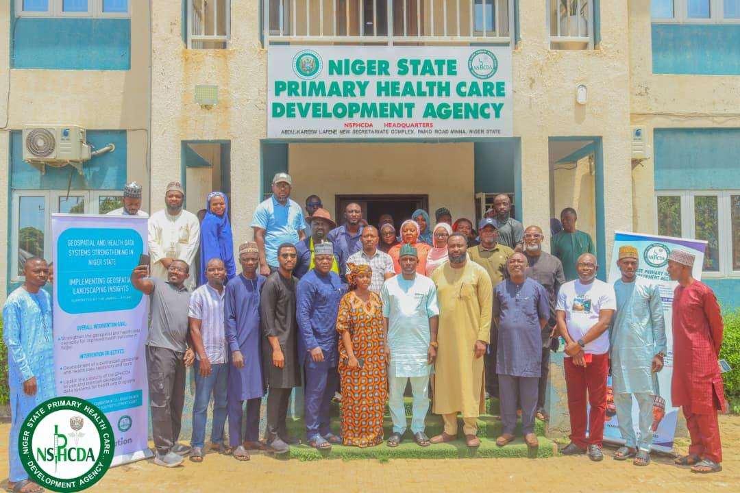

Submitted by: | Fact Foundation (FACT)
Funder: | Umbrella Fund
Implementation location | Niger State, Nigeria.
Submission Date | June, 2026

Executive Summary
The Geospatial and Health Data System Strengthening Project is an initiative of the Umbrella Fund implemented by Fact Foundation (FACT) in partnership with the Niger State Primary Health Care Development Agency (NSPHCDA), with technical support from Dev-Afrique Development Advisors.
The project seeks to strengthen geospatial and health data systems within Niger State to improve evidence-based planning, decision-making, resource allocation, and service delivery across the primary healthcare sector.
The project was conceived in response to findings from national and subnational geospatial capacity assessments, which identified significant challenges, including fragmented datasets, limited institutional ownership of health and geospatial information, weak data governance mechanisms, inadequate technical capacity, and the absence of a functional state-owned repository for managing and utilising geospatial health data.
As part of the inception phase, FACT conducted stakeholder consultations and strategic alignment engagements with representatives of NSPHCDA, programme teams, implementing partners, and other relevant stakeholders. These engagements validated project assumptions, identified implementation priorities, and generated insights that informed the project's implementation approach.
Key findings from the inception phase highlighted the need for improved data harmonisation, stronger governance mechanisms, enhanced technical capacity, sustainable institutional ownership, and increased application of geospatial intelligence within health sector planning and programme implementation.
In response, the project will focus on four integrated implementation workstreams:
- Planning, diagnostics, and repository framework development.
- Repository development and deployment.
- Capacity development and curriculum institutionalisation.
- Knowledge transfer, governance, and sustainability.
These workstreams will be implemented through a phased-but-parallel approach to ensure continuous stakeholder engagement, adaptive implementation, and progressive value delivery throughout the project lifecycle.
The project is expected to establish a functional state-owned geospatial and health data repository, strengthen technical capacity across state and local government levels, improve access to harmonised datasets, and institutionalise governance mechanisms that support sustainable use of geospatial information for health sector decision-making.

Executive Summary 2
1. Introduction 5
2. Project Background 5
3. Project Overview 6
Project Goal 7
Project Objectives 7
Scope of Work 7
Expected Outcomes 7
Long-Term Impact 8
4. Stakeholder Engagement and Inception Findings 8
Key Strategic Insights 8
5. Implementation Approach and Strategy 9
Implementation Principles 9
6. Project Implementation Workstreams 10
Phase 1: Planning, Diagnostics and Repository Framework Development 10
Purpose 10
Key Activities 10
Expected Deliverables 11
Contribution to Project Outcomes 11
Phase 2: Repository Development and Deployment 11
Purpose 11
Key Activities 12
Expected Deliverables 12
Contribution to Project Outcomes 12
Phase 3: Capacity Development and Curriculum Institutionalisation 12
Purpose 12
Key Activities 13
Expected Deliverables 13
Contribution to Project Outcomes 13
Phase 4: Knowledge Transfer, Governance and Sustainability 13
Purpose 13
Key Activities 13
Expected Deliverables 14
Contribution to Project Outcomes 14
7. Results Framework 14
8. Project Management and Governance 16
1. Umbrella Fund 16
Key responsibilities include: 16
2. Fact Foundation (FACT) 16
Key responsibilities include: 16
3. Niger State Primary Healthcare Development Agency (NSPHCDA) 17
Key responsibilities include: 17
4. Technical Working Group (TWG) 17
Key responsibilities include: 17
5. Data Governance Steering Committee (DGSC) 18
Key responsibilities include: 18
Communication and Reporting Framework 18
Reporting Structure 19
9. Risk Management 20
Risk Register 20
Risk Monitoring and Escalation 23
10. Activities Conducted During the Inception Phase 24
Internal Project Planning and Alignment 24
Stakeholder Engagement and Project Introduction 24
Multi-Stakeholder Inception Workshop 24
Initiation of the Technical Working Group 25
Repository Use Case Identification and Prioritisation 25
Capacity Development Partnership Engagement 25
Data Access and Technical Consultations 26
Key Outcomes of the Inception Phase 26
11. Immediate Next Steps 27
12. Conclusion 28
Annexes 29

1. Introduction
The Geospatial and Health Data System Strengthening Project is an initiative of the Umbrella Fund implemented by Fact Foundation (FACT) in partnership with the Niger State Primary Healthcare Development Agency (NSPHCDA), with technical support from Dev-Afrique Development Advisors.
The project seeks to strengthen geospatial and health data systems within Niger State to support more effective planning, decision-making, resource allocation, and service delivery across the primary healthcare sector. Through the development of a centralised geospatial and health data repository, capacity strengthening interventions, and improved governance mechanisms, the project aims to enhance the availability, accessibility, and utilisation of geospatial information for health sector programming.
This Inception Report presents the findings from activities conducted during the inception phase and outlines the implementation approach that will guide project delivery over the implementation period. The report documents key stakeholder engagement outcomes, implementation priorities, proposed workstreams, project management arrangements, and risk mitigation measures identified during project start-up.
The report serves as a reference document for project implementation and provides a shared understanding among stakeholders regarding the project's objectives, scope, implementation strategy, and expected results.

2. Project Background
The effective use of geospatial information has become increasingly important for strengthening health systems and improving public health outcomes. By integrating location-based data with health information systems, decision-makers are better equipped to identify service gaps, target interventions, allocate resources efficiently, and monitor programme performance.
Recognising the growing importance of geospatial intelligence within health systems, Dev-Afrique Development Advisors, with support from the Bill & Melinda Gates Foundation (BMGF), conducted a national assessment of Nigeria's geospatial data ecosystem between April and October 2022. The assessment examined the geospatial value chain across government institutions, development partners, academic institutions, civil society organisations, and private sector actors to identify opportunities and constraints affecting the use of geospatial data for development planning and service delivery.
Building on this work, a subnational geospatial capacity assessment was subsequently conducted across six polio-priority states, including Niger State. The objective was to identify state-level capacity gaps and investment opportunities for strengthening the use of geospatial technologies in health planning, particularly within primary healthcare and immunisation programmes.
The assessments revealed several systemic challenges within Niger State's health data ecosystem. These included fragmented and inaccessible datasets, limited interoperability between information systems, weak institutional ownership of geospatial and health data assets, inadequate governance structures, and limited technical capacity to independently manage and utilise geospatial information. Stakeholder consultations further highlighted the absence of a functional, centralised platform for managing geospatial and health data and a heavy reliance on external partners for geospatial analysis and technical support.
These challenges limit the ability of the Niger State Primary Healthcare Development Agency (NSPHCDA) and other stakeholders to fully leverage data for planning, monitoring, resource allocation, and evidence-based decision-making.
To address these gaps, the Umbrella Fund was established to provide catalytic investments aimed at strengthening geospatial and health data systems across Nigeria. Within this broader initiative, the Geospatial and Health Data System Strengthening Project was conceived to strengthen institutional capacity, improve data governance, enhance access to harmonised datasets, and establish sustainable systems for the management and use of geospatial information within Niger State's health sector.

3. Project Overview
The Geospatial and Health Data System Strengthening Project is implemented by Fact Foundation (FACT) in partnership with the Niger State Primary Healthcare Development Agency (NSPHCDA), with support from the Umbrella Fund and technical collaboration from Dev-Afrique Development Advisors.
The project seeks to strengthen geospatial and health data capacity within Niger State by improving the availability, accessibility, management, and utilisation of geospatial and health information for evidence-based planning, decision-making, and service delivery.
At the centre of the intervention is the development of a state-owned Geospatial and Health Data Repository that will serve as a central platform for integrating, storing, managing, and visualising priority geospatial and health datasets. The repository will support improved coordination across programmes, reduce data fragmentation, and provide decision-makers with timely and actionable insights.
Complementing the repository, the project will strengthen the technical capacity of health data personnel at state and local government levels, support the institutionalisation of geospatial health training through partnerships with academic institutions, and establish governance mechanisms that promote sustainable management and utilisation of health and geospatial data assets.

Project Goal
To strengthen geospatial and health data capacity to improve health outcomes in Niger State.

Project Objectives
The project will pursue two primary objectives:
- Develop a centralised geospatial and health data repository and tools
- Upskill the capacity of the NSPHCDA to use and maintain geospatial data systems for healthcare programs.

Scope of Work
To achieve these objectives, the project will undertake the following core activities:
- Stakeholder engagement, coordination, and alignment to ensure participation, ownership, and collaboration among key actors.
- Development of a repository framework and system architecture covering business, functional, technical, and governance requirements.
- Design, development, testing, and deployment of a centralised geospatial and health data repository.
- Capacity strengthening for health and geospatial data personnel across state and local government levels.
- Knowledge transfer, governance strengthening, and sustainability planning to support long-term ownership and maintenance of project outputs.

Expected Outcomes
The project is expected to contribute to the following outcomes:
- Establishment of a functional, state-owned geospatial and health data repository.
- Improved access to harmonised geospatial and health datasets across programmes and stakeholders.
- Enhanced technical capacity among health data personnel to collect, analyse, interpret, and utilise geospatial information.
- Strengthened governance and coordination mechanisms for the management and use of health and geospatial data.
- Increased application of geospatial insights to health sector planning, monitoring, and decision-making.
- Improved institutional ownership and sustainability of geospatial and health data systems within Niger State.

Long-Term Impact
The project is expected to contribute to the institutionalisation of geospatial intelligence within health sector planning and decision-making processes, reduce dependence on external technical support, and improve the efficiency, effectiveness, and equity of healthcare service delivery across Niger State, particularly for underserved and hard-to-reach populations.



4. Stakeholder Engagement and Inception Findings
As part of the inception phase, stakeholder engagement activities were conducted to validate project assumptions, identify operational priorities, and ensure alignment with the realities of the Niger State health ecosystem. The engagement process included:
- In-depth discussions with key stakeholders
- Convening events and workshops, which included:
  - Interactive sessions to discuss project goals, objectives and expected outcomes
  - strategic alignment mapping exercises,
  - use case mapping workshops,
  - And collaborative discussions

Key Strategic Insights
The stakeholder engagement process generated several important implementation insights:
- Weak Health Data Systems Are a Central Systemic Challenge: There is strong strategic alignment and stakeholder recognition around the need to strengthen health information systems and establish more reliable, integrated, and real-time data management processes.
- Centralised Data Management Is a High-Priority Need: Stakeholders consistently identified fragmented and inaccessible datasets as a major operational challenge. The repository is therefore expected to improve centralised access, coordination, and visibility across programs and stakeholders.
- Harmonisation and Interoperability Are Critical: The existence of duplicate and inconsistent datasets across programs and partners highlighted the importance of harmonisation and interoperability in repository design and implementation.
- Governance and Ownership Are Important Sustainability Considerations: Stakeholders emphasised the importance of strengthening state ownership of health and geospatial data systems and ensuring that governance mechanisms support long-term sustainability.
- Capacity Gaps Exist Across Multiple Levels: Participants identified varying levels of technical and analytical capacity across state, LGA, and ward-level actors, reinforcing the need for practical foundational training.
- Geospatial Intelligence Has Long-Term Strategic Potential: Stakeholders demonstrated a strong enthusiasm for the long-term application of geospatial intelligence as a tool for strengthening health system planning and decision-making. Participants highlighted its potential to support service coverage analysis, identify and monitor disease hotspots, improve the targeting of health interventions, and enhance operational planning and resource allocation. This widespread interest suggests that investments in geospatial capabilities could deliver significant value beyond the immediate project scope, providing a foundation for more evidence-based, efficient, and responsive public health programmes.
- Funding Constraints Remain a Major Barrier to Implementation: Funding constraints emerged as one of the most significant barriers to implementation across stakeholder discussions. Participants consistently highlighted inadequate state-level financing, limited resources for critical data validation activities, uncertainty around implementation timelines, and concerns regarding the long-term sustainability of proposed interventions. These challenges underscore the need for future initiatives to adopt realistic and phased implementation approaches, integrate sustainability considerations from the outset, strengthen resource mobilisation efforts, and maximise the use of existing systems, structures, and capacities to ensure effective and sustained implementation.
These findings have informed the implementation approach outlined in this report.

5. Implementation Approach and Strategy
The project will adopt a phased-but-parallel implementation approach, in which activities are organised into implementation workstreams for coordination and reporting purposes, while implementation occurs iteratively and in parallel throughout the project lifecycle.
This approach is intended to ensure that:
- Governance and sustainability considerations are integrated from the beginning,
- Stakeholder engagement remains continuous,
- Implementation remains adaptive,
- And ownership-building activities occur alongside technical implementation.

Implementation Principles
The implementation approach will be guided by the following principles:
- Stakeholder-Centred Implementation: Project activities will be informed by ongoing stakeholder engagement and operational realities within the Niger State health ecosystem.
- Iterative and Adaptive Execution: Implementation activities will evolve based on stakeholder feedback, implementation learnings, and operational needs.
- Alignment With Existing Systems: The project will seek to align with existing systems, workflows, and reporting structures where feasible.
- Sustainability and State Ownership: Implementation activities will prioritise long-term sustainability, institutional ownership, and continuity.
- Practical and Incremental Value Delivery: The project will focus on practical and achievable outputs capable of generating immediate operational value within the project scope.
- Interoperability and Harmonisation: Repository implementation activities will prioritise harmonisation, accessibility, and reduction of fragmentation across datasets.

6. Project Implementation Workstreams
Consistent with the project's phased-but-parallel implementation approach, activities will be organised across four complementary implementation workstreams. While each workstream has distinct objectives and deliverables, activities will be implemented iteratively throughout the project lifecycle to ensure continuous stakeholder engagement, adaptive learning, and progressive delivery of value.

Phase 1: Planning, Diagnostics and Repository Framework Development

Purpose
This phase will establish the strategic, technical, and governance foundations required for the successful implementation of the Geospatial and Health Data Repository. Building on the findings from inception engagements, the phase will generate the evidence required to inform repository design, implementation priorities, governance arrangements, and capacity development interventions.
The phase will focus on understanding the existing health and geospatial data ecosystem within Niger State, identifying priority use cases, assessing available datasets, mapping key stakeholders and users, and defining the requirements necessary for a sustainable and state-owned repository.

Key Activities
- Conduct stakeholder consultations and technical engagements with NSPHCDA, the Ministry of Health, development partners, and other relevant actors.
- Assess existing health and geospatial data assets, systems, repositories, and data management practices.
- Identify and prioritise high-value use cases for geospatial and health data utilisation.
- Map existing datasets and determine data harmonisation and integration requirements.
- Review applicable data governance policies, regulations, and institutional arrangements.
- Assess technical infrastructure, system interoperability requirements, and opportunities to leverage open-source technologies and digital public goods.
- Identify capacity gaps among repository users and administrators to inform the training programme.
- Develop and validate the repository framework and implementation requirements.

Expected Deliverables
- Project Inception Report.
- Repository Framework Document outlining:
  - Priority use cases;
  - Required datasets and data sources;
  - Data standards and integration requirements;
  - Repository governance considerations;
  - Functional and technical requirements for implementation.

Contribution to Project Outcomes
This phase will provide the strategic and technical foundation for repository development while ensuring that implementation is aligned with stakeholder priorities, operational realities, and sustainability considerations.

Phase 2: Repository Development and Deployment

Purpose
This phase will focus on the design, development, testing, and deployment of a functional centralised geospatial and health data repository for Niger State.
The repository will be developed using a lean and user-centred approach, beginning with a Minimum Viable Product (MVP) that supports a limited number of priority use cases identified during Phase 1. This approach will enable early demonstration of value, facilitate user feedback, and reduce implementation risks while establishing a scalable foundation for future expansion.
The repository architecture will prioritise interoperability, modularity, scalability, and the use of open-source technologies to support long-term sustainability and cost-effective maintenance.

Key Activities
- Establish a technical working group to support repository implementation.
- Validate and approve repository architecture and system requirements.
- Conduct user-centred design and prototyping activities.
- Configure repository infrastructure and data management systems.
- Harmonise and integrate priority geospatial and health datasets.
- Develop repository dashboards, visualisation tools, and analytical functionalities.
- Conduct user acceptance testing and technical validation exercises.
- Train designated repository administrators and technical focal persons.

Expected Deliverables
- Repository Architecture Validation Workshop Report.
- Functional Geospatial and Health Data Repository.
- Repository Deployment and Validation Report.

Contribution to Project Outcomes
This phase will establish a functional state-owned repository that improves access to harmonised datasets, reduces data fragmentation, and supports evidence-based planning and decision-making across health programmes.

Phase 3: Capacity Development and Curriculum Institutionalisation

Purpose
This phase will strengthen the technical capacity of health data personnel across Niger State to utilise geospatial information and effectively manage and apply data for planning, monitoring, and service delivery.
The phase will also support the adoption and localisation of the National Geospatial Data for Health Curriculum through collaboration with a selected academic institution. This partnership is intended to strengthen sustainability by embedding geospatial health data capacity development within an existing institutional framework.
Training interventions will be tailored to identified capacity gaps and delivered through two complementary learning tracks:
- Geospatial data analysis and application for health programmes.
- Repository administration, management, and utilisation.

Key Activities
- Engage NSPHCDA and the selected academic institution to define roles, responsibilities, and implementation arrangements.
- Localise the National Geospatial Data for Health Curriculum for the Niger State context.
- Develop training plans, learning resources, practical exercises, and assessment tools.
- Conduct pre-training assessments.
- Deliver training programmes across identified participant groups.
- Conduct post-training evaluations and learning assessments.
- Document lessons learned and training outcomes.

Expected Deliverables
- Localised Geospatial and Health Data Training Curriculum.
- Training Completion Report.
- Capacity Assessment and Evaluation Report.

Contribution to Project Outcomes
This phase will strengthen the ability of state, LGA, and programme-level personnel to collect, analyse, interpret, and utilise geospatial information for routine decision-making while reducing long-term dependence on external technical support.

Phase 4: Knowledge Transfer, Governance and Sustainability

Purpose
This phase will ensure the long-term sustainability, institutional ownership, and effective management of the repository beyond the project period.
Recognising that technology adoption is primarily an organisational change process, this phase will focus on governance, change management, operational readiness, and the transfer of technical knowledge and assets to NSPHCDA.
Activities under this phase will be implemented throughout the project lifecycle to ensure that sustainability considerations are integrated from the outset rather than addressed solely at project close-out.

Key Activities
- Establish governance structures to oversee repository management and data stewardship.
- Develop repository standard operating procedures and technical documentation.
- Define data governance, access, and data-sharing arrangements.
- Support change management and organisational adoption processes.
- Identify and support repository champions within NSPHCDA.
- Conduct advanced training and mentoring for repository administrators.
- Facilitate repository deployment, handover, and operational transition.
- Develop a sustainability and future expansion roadmap.

Expected Deliverables
- Repository Governance Framework.
- Technical Documentation and Standard Operating Procedures.
- Repository Handover Package.
- Sustainability and Integration Roadmap.

Contribution to Project Outcomes
This phase will strengthen state ownership, institutionalise governance mechanisms, and establish the foundations required for the continued operation, maintenance, and expansion of the repository beyond the lifespan of the project.

7. Results Framework
Goal | Objectives | Outputs | Output indicators | Outcomes | Outcome indicators
Strengthen geospatial and health data capacity to improve health outcomes in Niger. | Upskill the capacity of the NSPHCDA to use and maintain geospatial data systems for healthcare programs | Localised geospatial and health data curriculum | - Number of state, LGA and ward-level staff trained in geospatial data collection and analysis  - Percentage of trained participants completing all training modules | Early application of insights: Geospatial analysis will be applied early to priority health programs, such as immunisation and disease surveillance. | Reduction in time required to access and analyse geospatial health data for planning
 |  | Comprehensive training report across all levels |  | Enhanced technical capacity: State, Local Government Area (LGA), and ward-level health data teams will be better equipped to collect, analyse, and interpret geospatial data for routine decision-making. | Percentage improvement in geospatial knowledge and analytical skills among trained staff (pre/post assessment)
 |  | Evaluation report highlighting outcomes and results.
 | Develop a centralised geospatial and health data repository and tools | Established a geospatial and health data repository | Centralised geospatial data repository established and operational within the state environment | Establishment of a functional, state-owned geospatial health data repository: This centralised repository will be accessible to the Niger State Primary Healthcare Development Agency (NSPHCDA) and other stakeholders for planning and analysis. | Evidence of reduced duplication of datasets across PHC programs
 |  |  | Number of priority geospatial and health datasets integrated, standardised, and documented | Improved access to harmonised datasets: By linking existing repositories, the project will reduce data fragmentation and duplication across various primary healthcare (PHC) programs | Number of health programs actively using the geospatial repository for decision-making
 |  |  | Number of dashboards, maps or spatial analysis products developed for PHC planning |  | Number of planning documents or operational plans referencing geospatial outputs
 |  | Governance framework to ensure seamless asset and knowledge transfer to the NSPHCA. | Governance structures established with approved Terms of Reference | Data management: Improvements will be made in the overall management and storage of health and geospatial data.
 |  |  | Data sharing protocols and Standard Operating Procedures are approved and in use
 |  | Sustainability and integration roadmap | Sustainability and system handover plan developed and endorsed

8. Project Management and Governance
The project will adopt a multi-level governance structure to provide strategic oversight, technical guidance, implementation coordination, and long-term sustainability of project outputs. The governance structure is designed to promote stakeholder ownership, strengthen accountability, facilitate timely decision-making, and ensure alignment with the priorities of the Niger State health sector.

1. Umbrella Fund
The Umbrella Fund will provide overall strategic oversight of the project and serve as the primary funding partner.

Key responsibilities include:
- Providing strategic guidance and oversight.
- Reviewing project progress and key deliverables.
- Approving major project milestones where required.
- Providing feedback on implementation performance and results.
- Supporting learning and knowledge-sharing across related initiatives.

2. Fact Foundation (FACT)
FACT will serve as the lead implementing organisation and will be responsible for overall project delivery, coordination, reporting, and quality assurance.

Key responsibilities include:
- Overall project management and implementation.
- Stakeholder engagement and coordination.
- Repository design, development, and deployment.
- Capacity-building programme implementation.
- Monitoring, evaluation, and reporting.
- Risk management and mitigation.
- Knowledge transfer and sustainability planning.

3. Niger State Primary Healthcare Development Agency (NSPHCDA)
NSPHCDA will serve as the project owner and principal beneficiary institution.
The Agency will provide technical leadership and institutional direction throughout project implementation while ensuring alignment with state priorities and health sector needs.

Key responsibilities include:
- Providing strategic and technical guidance.
- Facilitating stakeholder engagement and participation.
- Supporting access to relevant datasets and information systems.
- Participating in repository design, validation, and testing.
- Identifying personnel for training and capacity development activities.
- Leading institutionalisation and long-term management of project outputs.
- Supporting sustainability and resource mobilisation efforts.

4. Technical Working Group (TWG)
A Technical Working Group will be established to provide technical oversight and support the implementation of repository-related activities.
The TWG will comprise representatives from NSPHCDA, FACT, relevant health programmes, information technology personnel, monitoring and evaluation teams, and other key technical stakeholders.

Key responsibilities include:
- Reviewing and validating repository requirements and architecture.
- Supporting dataset identification, validation, and harmonisation.
- Providing technical feedback throughout repository development.
- Supporting user acceptance testing and quality assurance activities.
- Advising on interoperability, data standards, and technical integration requirements.
- Supporting adoption and operationalisation of the repository.
The TWG will meet at least monthly and on an ad hoc basis as required.

5. Data Governance Steering Committee (DGSC)
A Data Governance Steering Committee will be established to strengthen institutional ownership and support the long-term sustainability of the repository and associated data systems.
The committee will comprise senior representatives from NSPHCDA and other relevant stakeholders responsible for data management, governance, and decision-making.

Key responsibilities include:
- Providing oversight on data governance matters.
- Reviewing and approving data-sharing arrangements and protocols.
- Supporting the development and adoption of governance frameworks and standard operating procedures.
- Resolving policy and governance issues affecting repository implementation.
- Promoting institutional ownership and sustainability.
- Supporting integration of repository operations into existing state structures and processes.
The DGSC will meet quarterly or as required to address governance and sustainability issues.
This governance structure will ensure that strategic oversight, technical implementation, and sustainability planning occur concurrently throughout the project lifecycle, thereby strengthening institutional ownership and supporting the long-term use and maintenance of project outputs beyond the grant period.

Communication and Reporting Framework
The project will adopt a structured communication and reporting approach to ensure effective coordination, timely decision-making, stakeholder alignment, and accountability throughout implementation.
Activity | Frequency | Purpose | Tools/Channels
Project Tracking | Weekly | Monitor implementation progress against workplans, deliverables, milestones, risks, and dependencies | Google Sheets, Asana/Trello
Internal Team Coordination | Daily and as required | Coordinate implementation activities, resolve operational issues, and track emerging risks | Google Chat, Phone Calls
Activity Tracking | Daily | Monitor completion of tasks and implementation status across workstreams | Asana/Trello
Progress Reporting | Bi-weekly | Provide implementation updates, identify challenges, and agree on corrective actions | Progress Reports, Google Docs
Milestone Reporting | After key milestones | Document achievement of major deliverables and project outputs | Umbrella Fund Milestone Reporting Templates
Stakeholder Briefings | Monthly and as required | Update key stakeholders on project progress, decisions, risks, and next steps | Meetings, Presentations, Briefing Notes
Deliverable Reporting | Upon completion of deliverables | Provide formal documentation of completed project outputs for review and approval | Deliverable Reports

Reporting Structure
Project reporting will be conducted at four levels:
- Operational Reporting – Daily and weekly coordination focused on implementation activities, task completion, and issue resolution.
- Progress Reporting – Bi-weekly reporting against workplans, milestones, risks, and implementation priorities.
- Deliverable Reporting – Submission of completed outputs and technical deliverables for review and validation.
- Donor Reporting – Periodic reporting aligned with Umbrella Fund requirements, including progress updates, results achieved, challenges encountered, and mitigation actions.
This communication and reporting framework will support transparency, accountability, and timely decision-making while ensuring stakeholders remain informed and engaged throughout project implementation.

9. Risk Management
Effective risk management will be critical to the successful implementation and sustainability of the Geospatial and Health Data System Strengthening Project. The project will adopt a proactive approach to risk identification, monitoring, mitigation, and escalation throughout implementation.
Risks will be reviewed during weekly project management meetings and incorporated into routine progress reporting. High-priority risks will be escalated to relevant governance structures, including the Technical Working Group (TWG), Data Governance Steering Committee (DGSC), NSPHCDA leadership, and the Umbrella Fund, where necessary.
The project's phased-but-parallel implementation approach also serves as a risk mitigation strategy by enabling continuous stakeholder engagement, iterative validation, early identification of challenges, and progressive delivery of project outputs.

Risk Register
Risk/Challenge | Probability (1–5) | Impact (1–5) | Risk Score | Mitigation Measures
Leadership turnover or changes in institutional priorities within NSPHCDA | 3 | 5 | 15 | Secure formal institutional commitments and approvals; engage multiple levels of leadership; document decisions and implementation agreements; establish governance structures that remain functional despite personnel changes.
Limited institutional ownership of the repository and associated governance structures | 3 | 5 | 15 | Integrate NSPHCDA personnel into repository design and implementation activities; establish the TWG and DGSC early; identify repository champions; implement structured knowledge transfer and change management activities.
Delays in accessing priority datasets required for repository development | 3 | 4 | 12 | Develop data-sharing arrangements early; maintain a dataset acquisition tracker; prioritise integration of readily available datasets while resolving access constraints; escalate delays through governance structures where necessary.
Data quality issues, including incomplete, outdated, or inconsistent datasets | 3 | 4 | 12 | Implement data quality assessment procedures; document metadata and provenance; conduct targeted validation and data cleaning exercises; prioritise high-value datasets for early quality assurance.
Low adoption of the repository by intended users | 3 | 5 | 15 | Prioritise user-centred design; develop repository functionalities around validated use cases; demonstrate quick wins; provide ongoing mentoring and technical support; integrate repository use into existing planning and review processes.
Technical challenges affecting repository interoperability or integration with existing systems | 2 | 4 | 8 | Conduct early technical assessments; adopt open standards and interoperable architecture; engage relevant technical stakeholders through the TWG; conduct iterative testing and validation.
Staff transfers, competing priorities, or limited availability of participants for training and mentoring activities | 4 | 4 | 16 | Agree on training schedules in advance; identify alternate participants; provide training materials and self-paced resources; maintain mentoring support and documentation to support continuity.
Training content does not adequately address identified capacity gaps | 2 | 4 | 8 | Conduct pre-training assessments; validate curriculum content with NSPHCDA and stakeholders; adapt training materials based on participant needs and feedback.
Delayed establishment or ineffective functioning of governance structures (TWG and DGSC) | 3 | 4 | 12 | Secure leadership endorsement early; develop clear Terms of Reference; define roles and responsibilities; integrate governance activities into the project workplan and reporting processes.
Resistance to organisational change and new data management processes | 3 | 4 | 12 | Implement change management activities throughout the project; communicate benefits clearly; engage users in design and validation processes; recognise and support early adopters.
Funding limitations for long-term maintenance and sustainability of repository infrastructure | 3 | 5 | 15 | Develop a costed sustainability roadmap; identify resource requirements early; support integration of repository management costs into agency planning and budgeting processes; explore partnerships for future support where appropriate.
Competing programme priorities and public health campaigns affecting implementation timelines | 4 | 3 | 12 | Align implementation schedules with state programme calendars; maintain flexibility in activity sequencing; utilise shorter engagement formats where necessary.
Scope expansion beyond approved project objectives, timelines, or resources | 3 | 4 | 12 | Apply formal change management procedures; prioritise approved use cases and deliverables; review proposed scope changes through governance structures before approval.

Risk Monitoring and Escalation
Risk monitoring will be integrated into routine project management processes. Risks will be reviewed on a weekly basis by the project team, with mitigation actions tracked through the project workplan.
Where risks have the potential to significantly affect project outcomes, sustainability, timelines, or stakeholder commitments, they will be escalated to the appropriate governance body for review and action.
The Technical Working Group will provide oversight on technical and implementation risks, while the Data Governance Steering Committee will oversee risks relating to governance, sustainability, institutional ownership, and long-term repository management. Strategic risks with significant implications for project delivery will be communicated to NSPHCDA leadership and the Umbrella Fund through established reporting mechanisms.

10. Activities Conducted During the Inception Phase
The inception phase focused on stakeholder engagement, strategic alignment, institutional relationship-building, governance establishment, technical consultations, and implementation planning. These activities were undertaken to validate project assumptions, strengthen stakeholder ownership, identify implementation priorities, and establish the foundations required for successful project delivery.

Internal Project Planning and Alignment
The project commenced with an internal planning session involving the FACT Foundation project team. The meeting focused on clarifying project objectives, aligning implementation approaches, defining stakeholder engagement strategies, and preparing for engagements with key stakeholders within the Niger State Primary Healthcare Development Agency (NSPHCDA).
This activity ensured a shared understanding of project goals, stakeholder management approaches, and expected outcomes before project commencement.

Stakeholder Engagement and Project Introduction
A series of introductory and strategic engagement meetings were conducted with senior leadership and technical personnel within the NSPHCDA, including the Executive Director, the Director of Planning, Research and Statistics (DPRS), and the Director of Disease Control and Immunisation.
These engagements served to formally introduce the project, clarify its objectives and implementation approach, and obtain stakeholder perspectives on existing challenges affecting health and geospatial data management within the state. Stakeholders expressed strong support for the intervention and highlighted the need for a state-owned system capable of improving access to and utilisation of health and geospatial data for planning and decision-making.
The discussions also facilitated the identification of key focal persons, relevant datasets, and institutional priorities that would inform subsequent project activities.

Multi-Stakeholder Inception Workshop
An inception workshop was convened, bringing together representatives from NSPHCDA, implementing partners, and other relevant stakeholders within the health and data ecosystem.
The workshop provided an opportunity to introduce the project to a broader stakeholder audience, present the project's objectives and expected outcomes, and validate stakeholder expectations. A strategic alignment exercise was subsequently conducted to understand the state's priorities, identify key challenges affecting health data systems, and explore opportunities for alignment with ongoing initiatives.
The exercise generated valuable insights into stakeholder needs, implementation priorities, and opportunities for collaboration that have informed the project's implementation strategy.

Initiation of the Technical Working Group
In collaboration with the Director of Planning, Research and Statistics, the project team initiated the establishment of a Technical Working Group (TWG) comprising representatives from programme teams, monitoring and evaluation units, and information technology personnel.
The TWG is intended to serve as a key institutional mechanism for providing technical guidance, validating project deliverables, supporting repository development, and promoting state ownership of project outputs. The establishment of the TWG represents an important step toward institutionalising technical oversight and strengthening sustainability beyond the project period.

Repository Use Case Identification and Prioritisation
A technical workshop was conducted with members of the Technical Working Group to explore and prioritise potential use cases for the proposed Geospatial and Health Data Repository.
Participants identified a strong need for a centralised and integrated repository capable of improving access to health and geospatial data across programmes. Key priority areas identified included evidence-based planning and decision-making, data accessibility, performance monitoring, disease surveillance, data quality improvement, and geospatial analysis.
The exercise also highlighted stakeholder concerns regarding data governance, ownership, and sustainability, reinforcing the importance of incorporating governance mechanisms into repository design and implementation. The findings from this activity directly informed repository requirements, implementation priorities, and the project's governance strategy.

Capacity Development Partnership Engagement
The project team engaged the Department of Geography at the Federal University of Technology, Minna (FUT Minna) to explore opportunities for institutionalising geospatial health capacity development within the state.
Discussions focused on potential collaboration around the National Geospatial Health Curriculum, opportunities for curriculum localisation, and mechanisms for strengthening long-term geospatial capacity within Niger State. Relevant project documentation and curriculum materials were shared with the university for consideration and feedback.

Data Access and Technical Consultations
The project team conducted a series of technical consultations with the DPRS, Disease Control and Immunisation Department, and the NSPHCDA Information and Communication Technology (ICT) team to facilitate access to priority datasets required for repository development.
These engagements revealed stakeholder concerns relating to data quality, validation processes, and data security. In response, the project team worked collaboratively with the ICT department to establish an appropriate pathway for data access and reassure stakeholders regarding compliance with data protection and security requirements.
The consultations ultimately resulted in access to selected datasets that will support repository development while also providing important insights into data governance considerations that will need to be addressed throughout implementation.

Key Outcomes of the Inception Phase
The inception phase resulted in several important achievements that have strengthened implementation readiness, including:
- Secured stakeholder buy-in and institutional support for project implementation.
- Identification and engagement of key technical and leadership stakeholders.
- Initiation of the Technical Working Group establishment process.
- Validation of priority challenges affecting health and geospatial data systems.
- Identification and prioritisation of high-value repository use cases.
- Initial access to priority datasets required for repository development.
- Exploration of partnerships to support long-term capacity development.
- Improved understanding of governance, sustainability, and institutional ownership requirements.
- Refinement of the project's implementation strategy based on stakeholder feedback and operational realities.
Collectively, these activities have established a strong foundation for the implementation of the Geospatial and Health Data System Strengthening Project and have informed the design of the project's technical, governance, capacity development, and sustainability interventions.

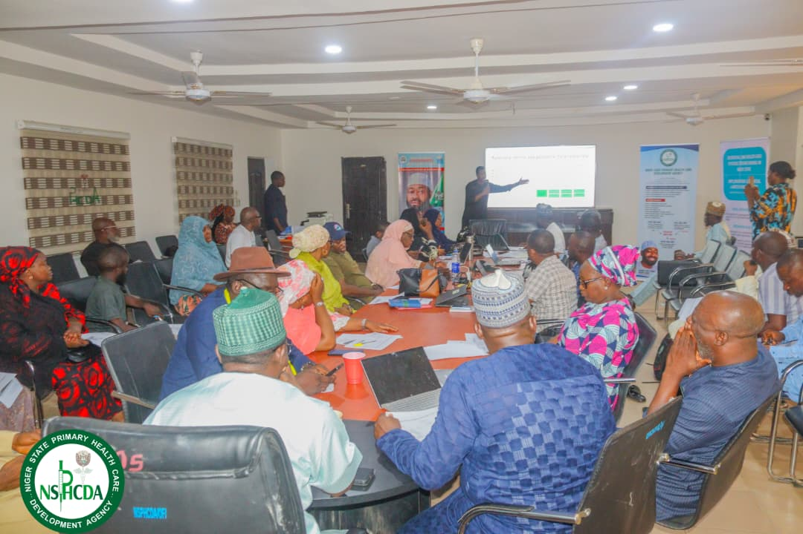

11. Immediate Next Steps
Following completion of the inception phase, the project will transition into implementation activities focused on establishing the technical, governance, and institutional foundations required for successful delivery of project objectives.
The immediate priorities for the next phase of implementation include:
Establishment and Operationalisation of Governance Structures: The project will support the formal inauguration and operationalisation of the Technical Working Group (TWG) and initiate the establishment of the Data Governance Steering Committee (DGSC). Terms of Reference will be developed and validated to clarify roles, responsibilities, reporting arrangements, and decision-making processes.
Finalisation of Institutional Agreements: The project team will continue engagement with NSPHCDA leadership to finalise and execute the Memorandum of Understanding (MoU), providing a formal framework for collaboration, stakeholder responsibilities, and implementation oversight.
Repository Framework Development: Building on findings from stakeholder consultations and use case prioritisation exercises, the project team will commence development of the repository framework, including:
- Validation of priority use cases;
- Mapping and prioritisation of datasets;
- Definition of functional and technical requirements;
- Identification of interoperability requirements;
- Development of governance and data management requirements.
Data Acquisition and Assessment: The project team will continue working with NSPHCDA departments and the ICT team to secure access to additional datasets required for repository development. Concurrently, data quality assessments will be undertaken to identify gaps, inconsistencies, and harmonisation requirements.
Repository Architecture and Design: The project will initiate repository architecture design activities, including system modelling, infrastructure planning, and validation of technical requirements through engagement with the Technical Working Group and other relevant stakeholders.
Capacity Development Planning: Engagements with academic and technical partners will continue to support localisation of the National Geospatial Health Curriculum and development of a capacity-building plan aligned with identified skills gaps and institutional priorities.
Sustainability and Change Management Planning: The project team will commence development of governance, knowledge transfer, and sustainability frameworks to ensure that institutional ownership, operational readiness, and long-term maintenance considerations are integrated throughout implementation rather than addressed solely at project close-out.
Collectively, these activities will establish the foundations required for repository development, capacity strengthening, and sustainable institutionalisation of geospatial and health data systems within Niger State.

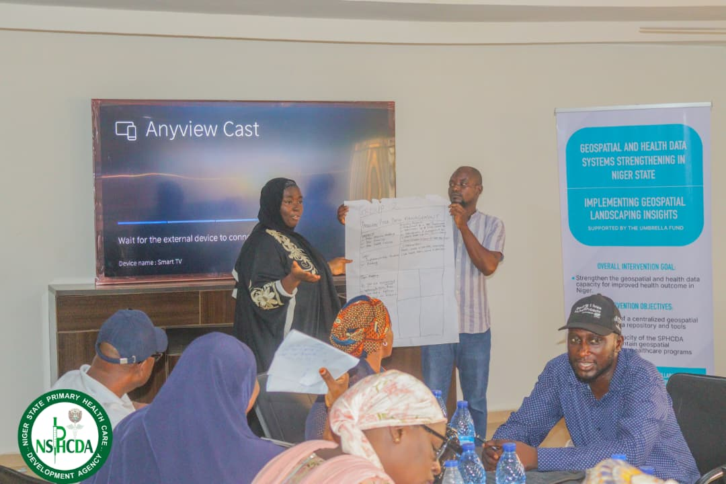

12. Conclusion
The inception phase provided an important opportunity to engage stakeholders, validate project assumptions, assess implementation realities, and establish a shared understanding of the objectives and expected outcomes of the Geospatial and Health Data System Strengthening Project.
Stakeholder consultations and technical engagements confirmed the relevance and timeliness of the intervention, while highlighting persistent challenges relating to data fragmentation, accessibility, governance, institutional ownership, and technical capacity. These findings reaffirm the need for a coordinated approach to strengthening geospatial and health data systems within Niger State.
The inception phase also generated valuable insights that have informed the project's implementation strategy, repository design approach, governance arrangements, and capacity development priorities. Importantly, the engagements secured stakeholder buy-in, strengthened institutional partnerships, and initiated the establishment of governance structures that will support long-term ownership and sustainability of project outputs.
The project is therefore well-positioned to transition from inception to implementation. Through the development of a state-owned Geospatial and Health Data Repository, strengthening of technical capacities, and establishment of sustainable governance mechanisms, the project is expected to contribute to improved access to data, stronger evidence-based decision-making, and enhanced health sector planning and service delivery across Niger State.
By placing equal emphasis on technology, institutional capacity, governance, and sustainability, the project seeks not only to deliver a functional repository but also to strengthen the systems and capabilities required for the long-term use of geospatial intelligence in improving health outcomes for the people of Niger State.

